

**Module Title**

**Introduction to Programming**

**Assessment Weightage & Type**

**60% Individual Coursework**

**Year**

**2023-24**

**Student Name: Nikita Chaudhary**

**UWE ID: 23085220**

**Assignment Due Date: April 12, 2024**

**Assignment Submission Date:**

1. Write a program in Javascript to create variables to store numeric, float, string and

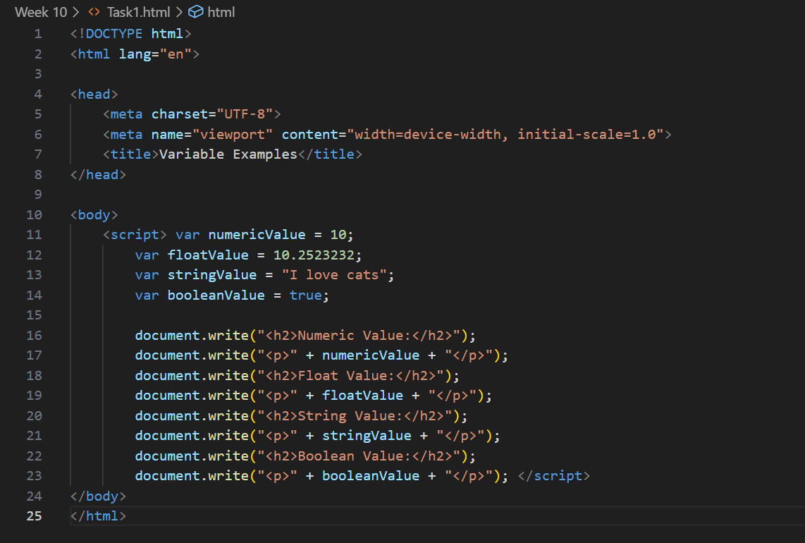Boolean values and show them in page with document.write() function.

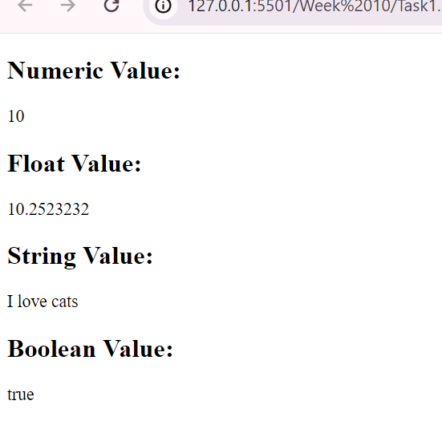

2. Write a program to input two data values for Your Name and Student Id in prompt

dialog boxes and show them in alert dialog box.

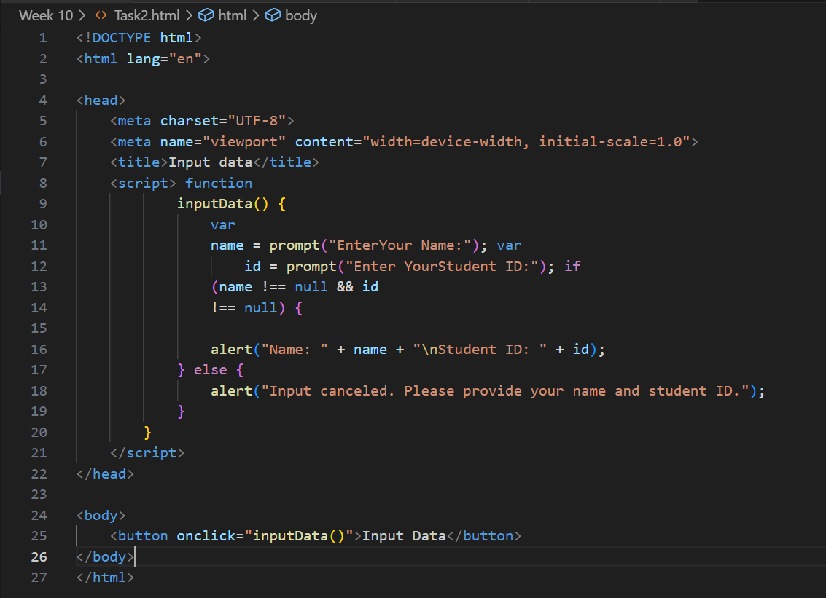

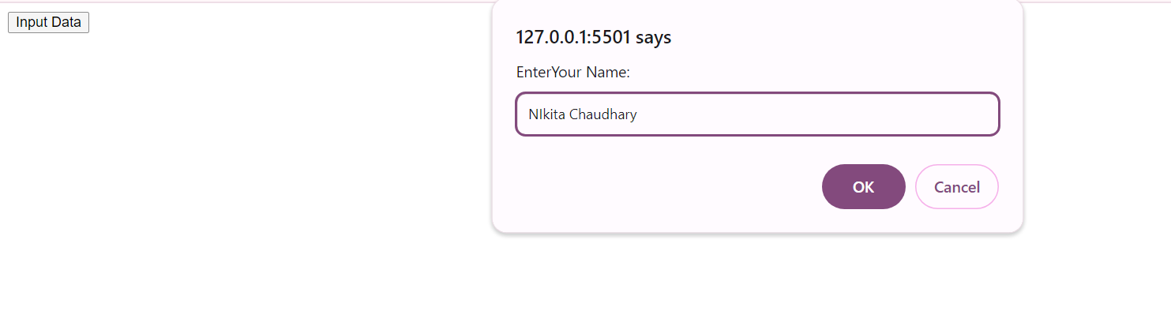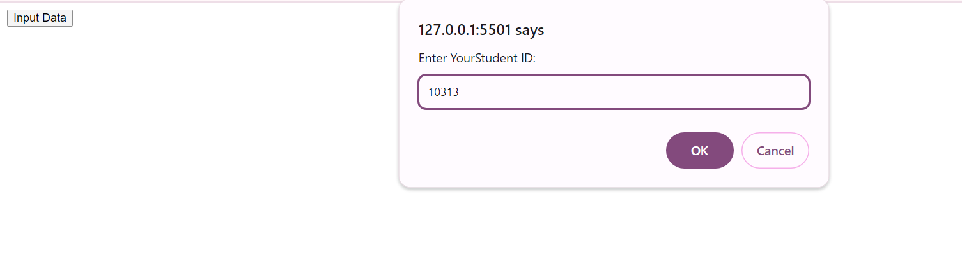

3. WAP to show the use if .... Else if .... else for following conditions:

a. For marks > = 80 and marks <=100, show Distinction

b. For marks >=60 and marks < 80, show First Division

c. For marks >=50 and marks < 60, show Second Division

d. For marks >=40 and marks <50, show Third Division

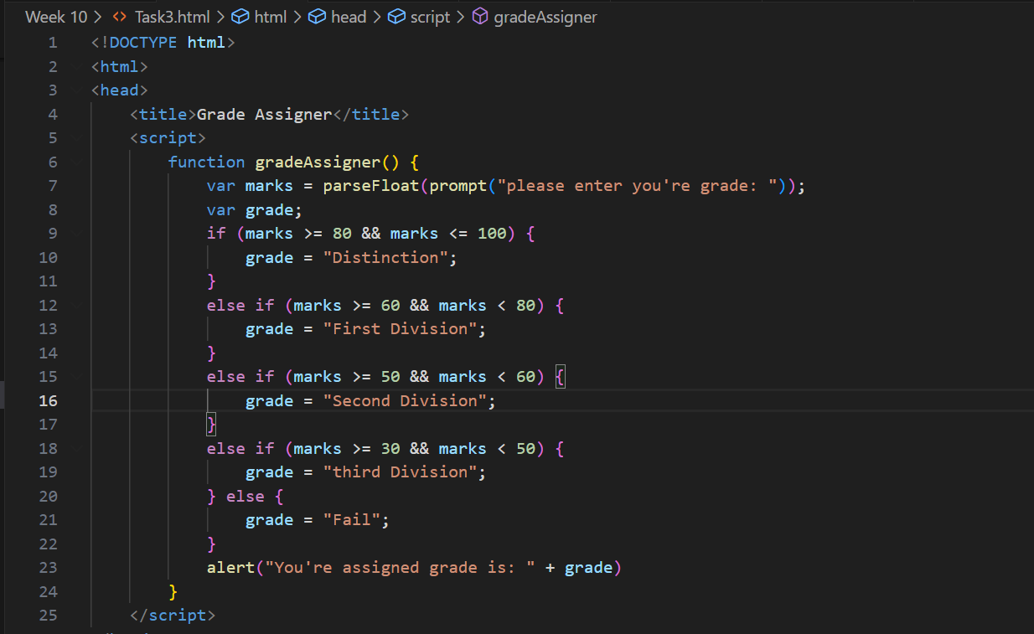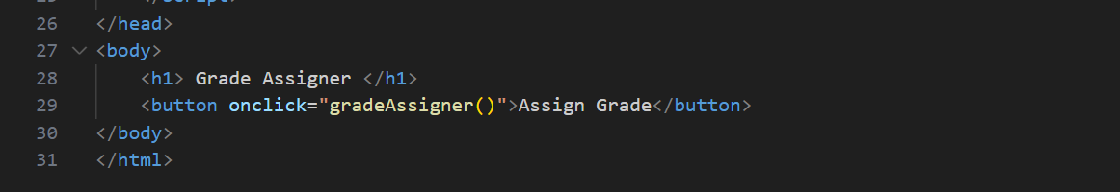e. For marks < 40, show Fail

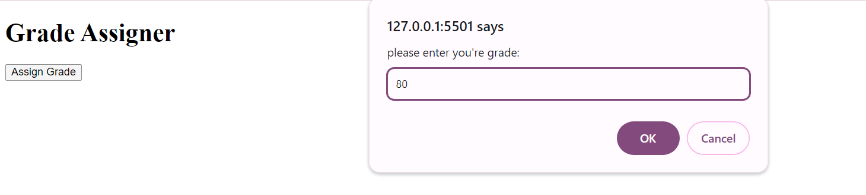

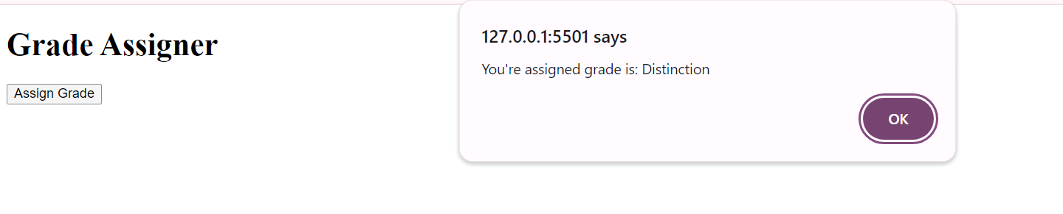

4. WAP to get number input with prompt dialog dox and show the Day using switch case

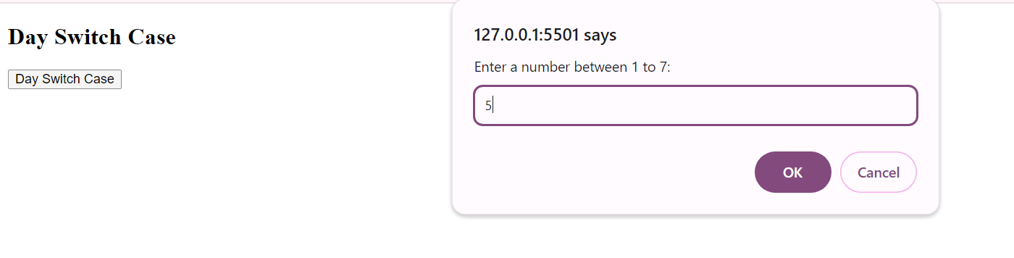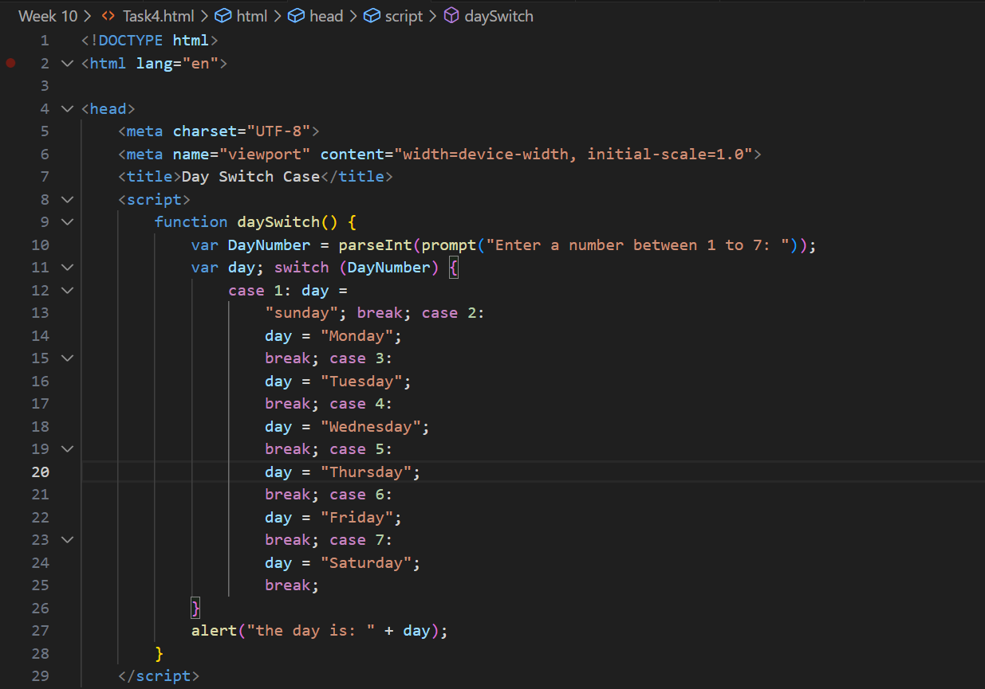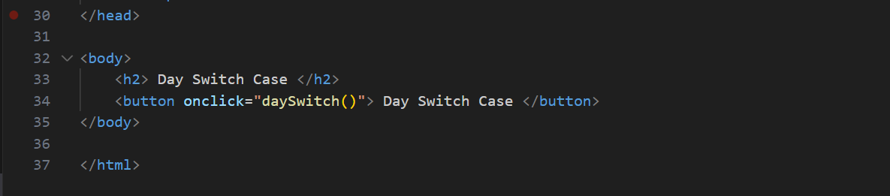

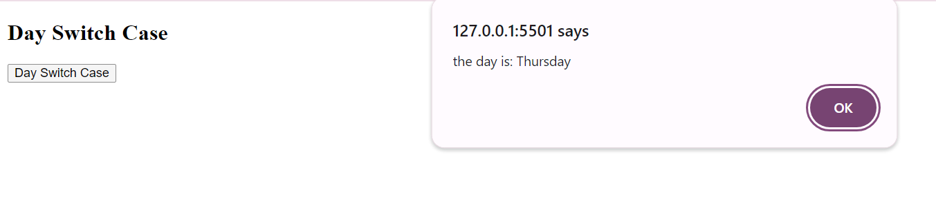

5. WAP in javascript using for loop to display 4 images with image name as 1.jpg, 2.jpg, 3.jpg and

4.jpg.

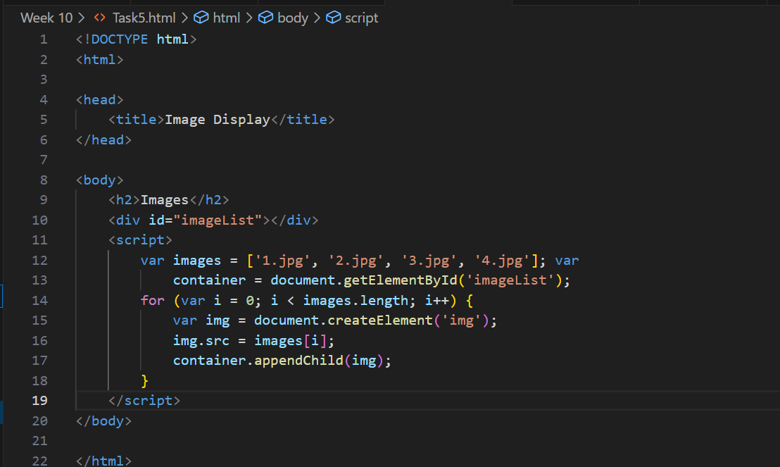

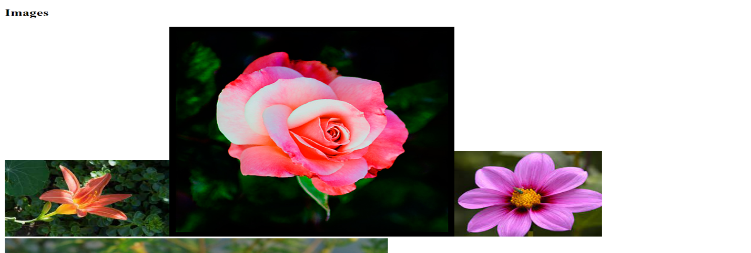

6. WAP to display multiplication number of 5 as follows:

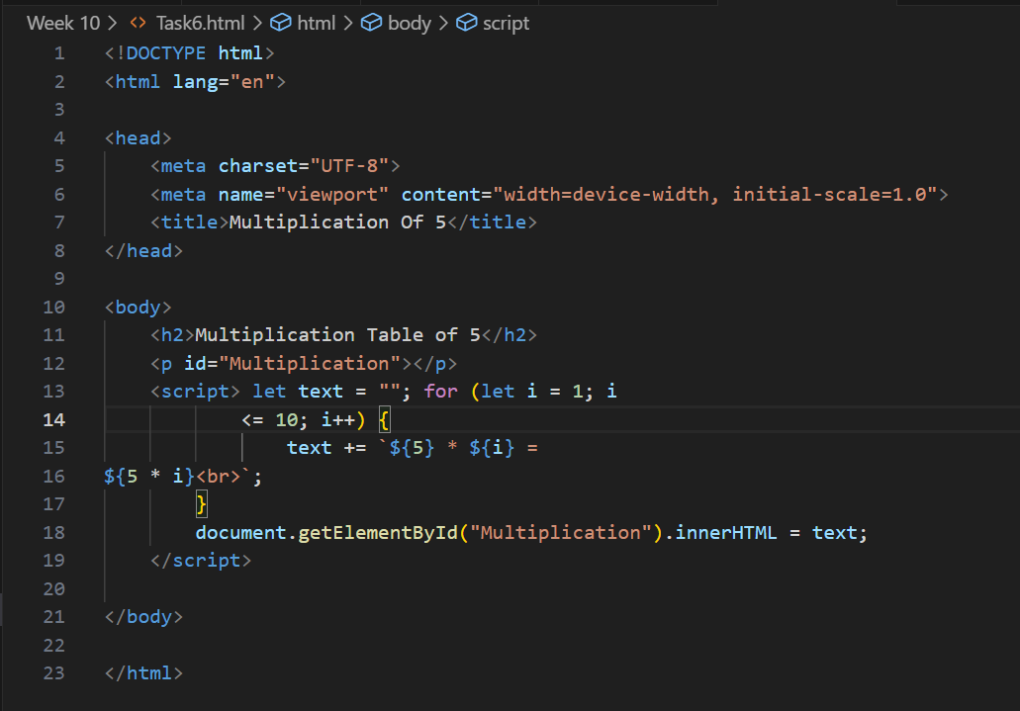

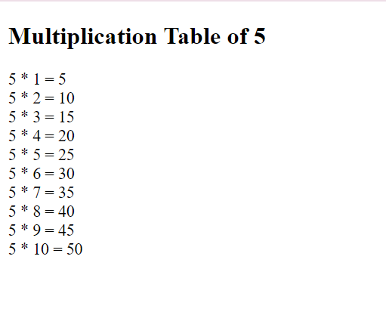

7. WAP in javascript using loop to display following table layout and with alternate background

color on data rows

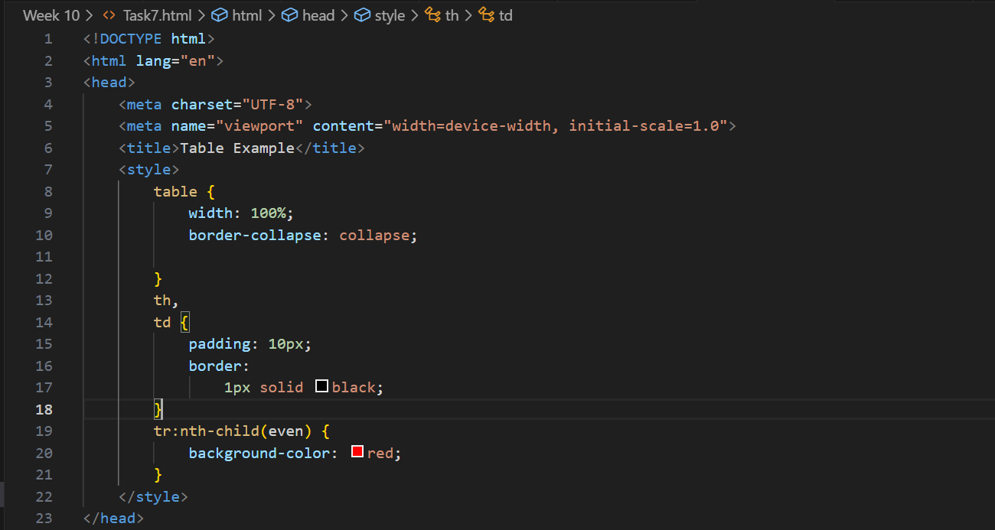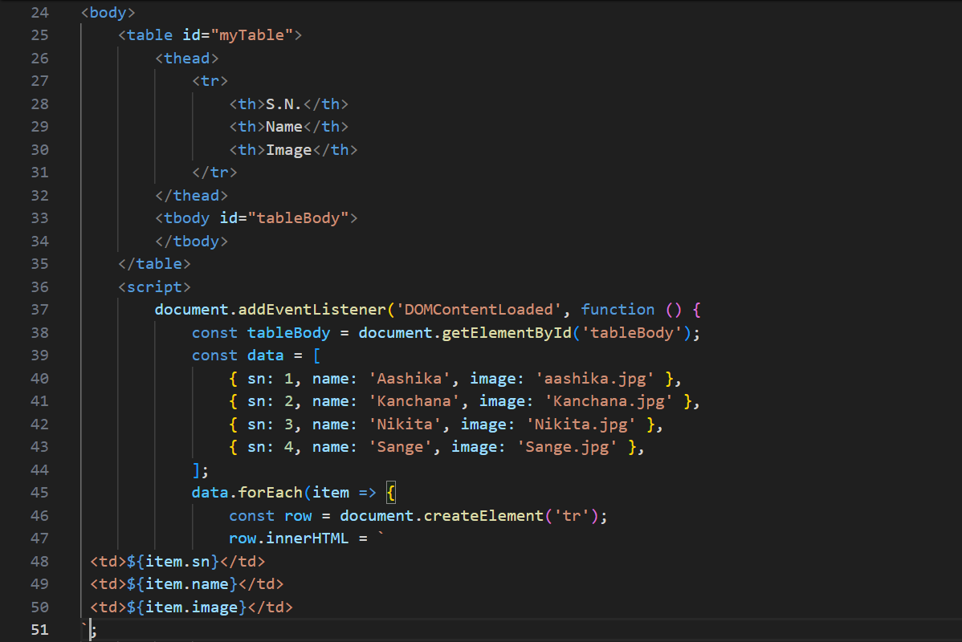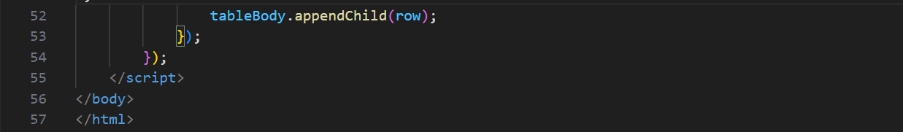

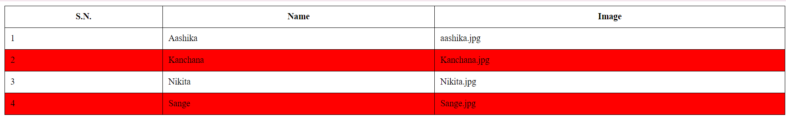

8. Write a simple JavaScript program to join all elements of the following array into a

string. Sample array : myColor = ["Red", "Green", "White", "Black"];

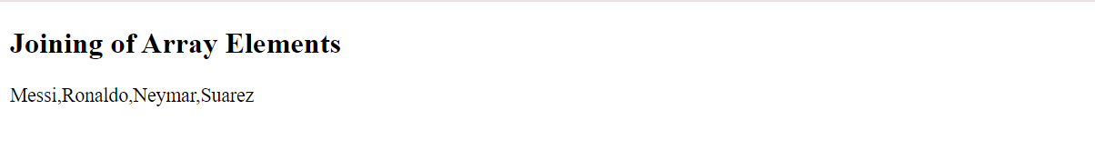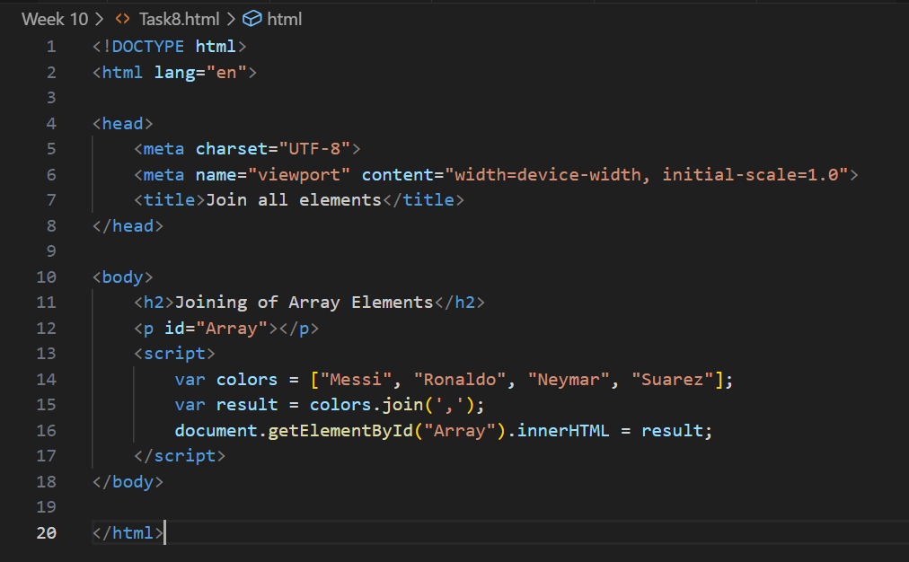

9. Write a JavaScript program to compute the sum and product of an array of integers.

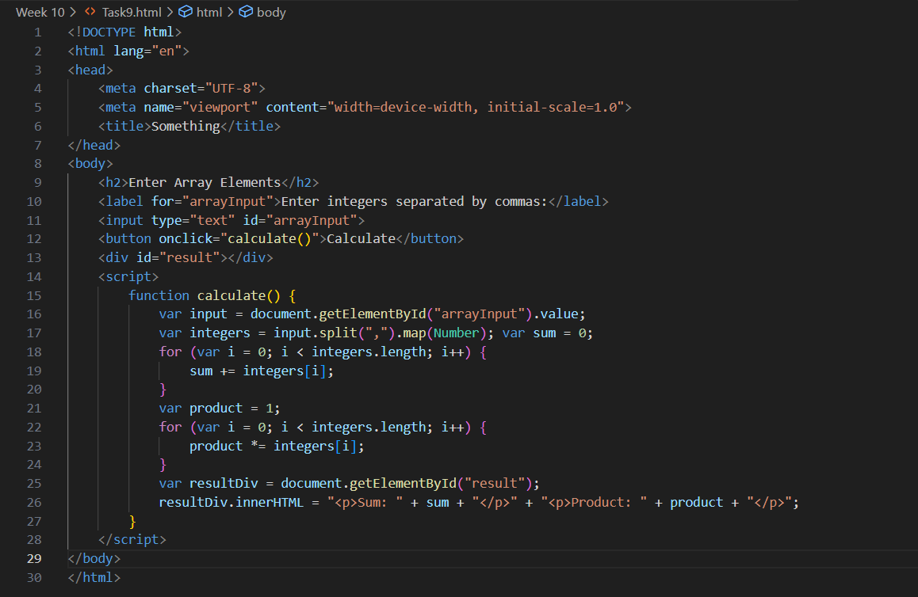

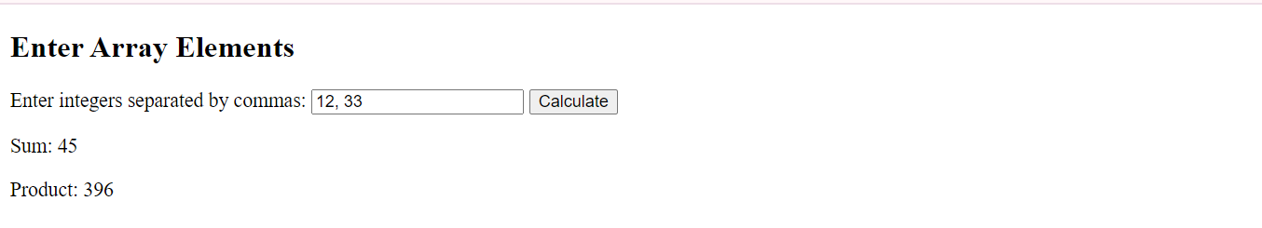

10. Write a Javascript function to calculate area of rectangle which accepts two parameters

– length and breadth.

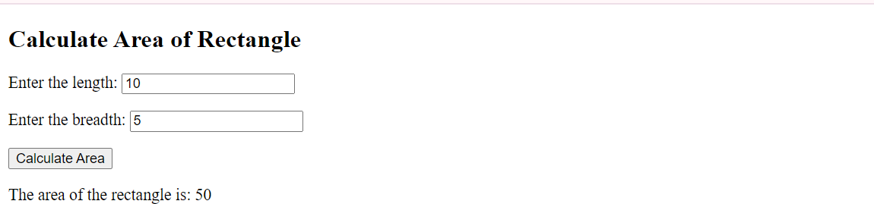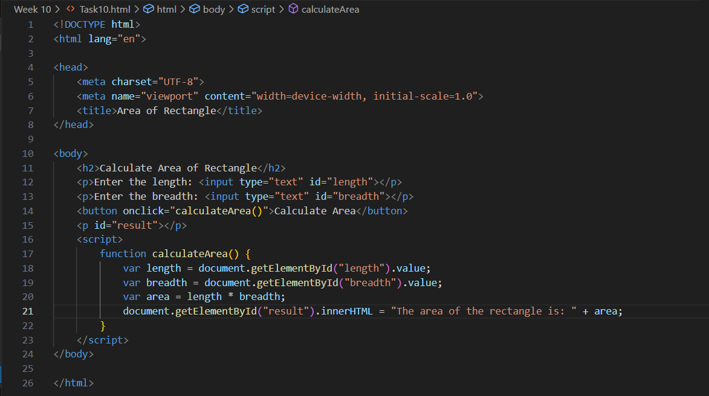

11. Write a JavaScript program to add items in an blank array and display the items using

function.

